

Electronic Client Record (ECR)

1 Electronic Client Record (ECR)

ECR is a web-based application, the module covers indicators of Family Planning, General Health Services and LARC Removal. It consists of internally configurable options, using built-in CMS. The services data is automatically aggregated in cLMISreports and analytics.

1.1ECR Landing Page

This page presents asummarized view of the overall informationof facility based on facility status, number of visits at specific facility, total number of clientsand the corresponding total number of visits.

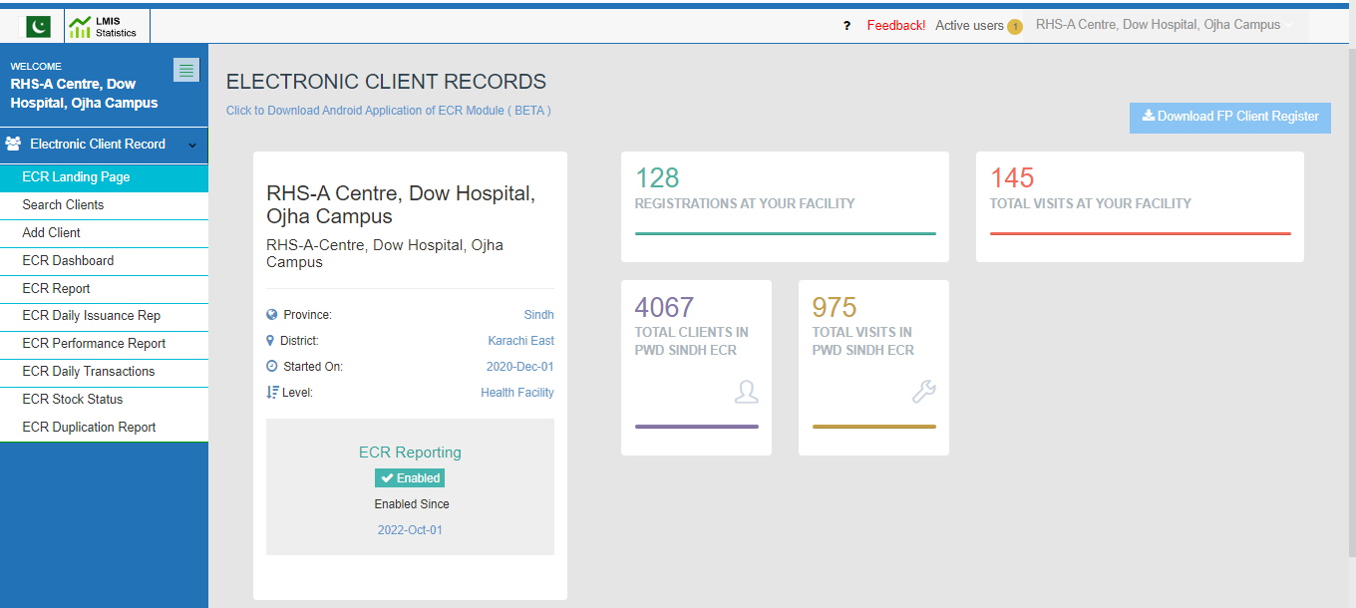

1.2 Search Client

Through Search Client menu,user can search the client using any keyword via patient name, father name, CNIC, CRC number etc. to filter the matching records. On search results all client details and corresponding visit details are displayed.The system also allows the user to edit an existing visit or client onformation or add a new visit for registered clients in search client.

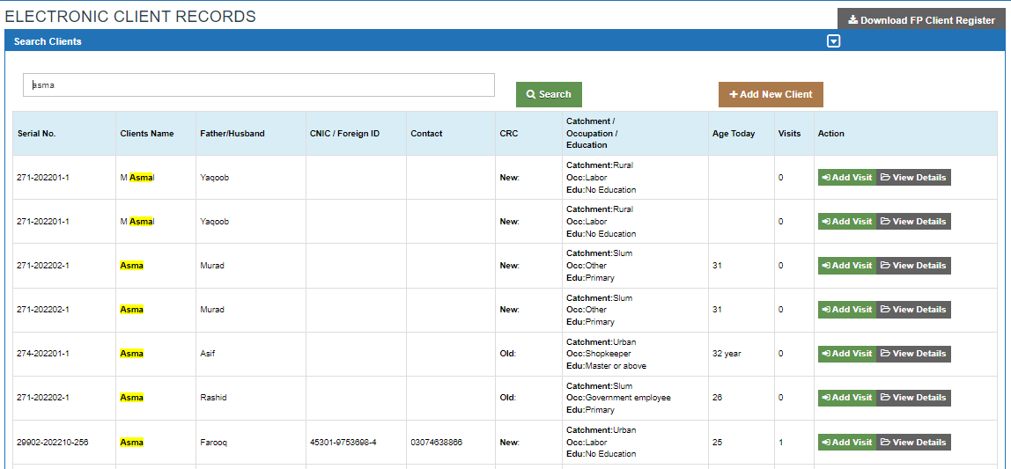

1.3Add Client

For new client registration click Add Client displayed under Electronic Client Record menu. Following are the required client details for new client registration:

* **Serial Number/Registration Number**: A system generated number to uniquely identify a register patient
* **Identification of Client** :Nationality of the patient
* **CNIC Number of Client:** National identity card number of the client
* **Date of Registration:**Date on which the client is registered
* **CRC Old/New:**Specify if the client is already registered against the CRC number
* **CRC Number:** The Client Registration Number
* **Clients Name:** Full Name of the client
* **Husband/Father Name:** Full name of Guardian
* **Complete Address:** Detailed address of the client
* **Catchment Area:** Specify if client is from rural, urban or slum area
* **Contact Number:** Contact details of the client

1.4ECR Dashboard

It visually representsoverall analytics of data in the form of following dashboards:

* FP method wise visits at your facility
* Method mix at your facility
* General health services
* Implanon removals with reasons at your facility
* IUCD removals with reasons at your facility
* Jadelle removals with reasons at your facility
* Age at your facility
* Education at your facility
* Occupation at your facility
* Demographic characteristics at your facility
* Parity alive at your facility

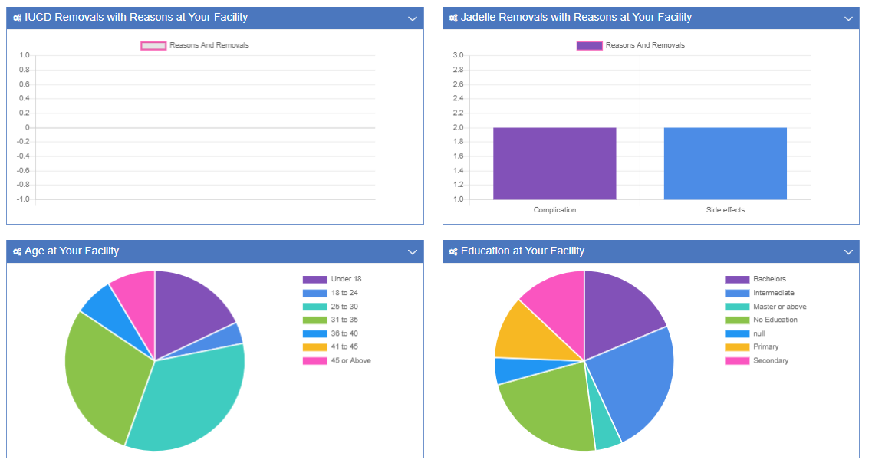

1.5ECR Indicator Based Report

The ECR Indicator based Report reflectsdata based on the indicator selected.

1.6ECR Daily Issuance Report

The report shows the issuance details of the product issued by the centres within the selected date range. Based on date of visit and item selected user can further drill down the data and can see the visits record.

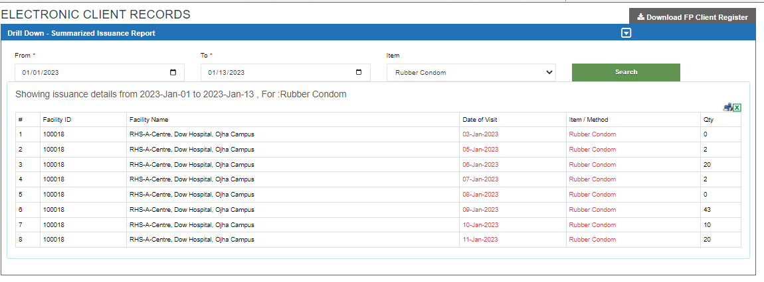

1.7ECR Performance Report

This report presents the detailed summary of the client registration, visits and purpose of the visits. User can further drill down the report to view the description of the client visits performed.

1.8ECR Stock Status

Based on their daily issuance report, livestock tracking of products can be seen in stock status.

